An Introduction to Executive Function for Faculty
A companion document to the EF Toolbook for Students

The Top 7 by PHILIPPE ERNEWEIN, MA, Director of Education, Denver Academy.

Sponsored and edited by the Accessibility Operations Team and Faculty Assembly Disability Committee. For further information, please contact the FA Disability Committee and see our site https://www.ucdenver.edu/faculty-staff/faculty-assembly/denver-campus/denver-campus-committees/faculty-assembly-committees/disabilities-committee/
Copyright 2025



\

Introduction

Executive functioning skills are imperative to the success of our students. As instructors furthering our understanding of the executive functioning skills and challenges our students face can help us to aid in their success. Executive function frustrations are some of the most mentioned issues among college students and are tied to conditions such as ADHD, anxiety, depression as well as other conditions that may impact student performance. This presentation introduces faculty to understanding and supporting the EF needs of our students. This document is intended as a supplement to the EF toolbook for students, Please consult and share the toolbook with your students; it contains for specific tools and techniques targeted to the EF areas discussed here. An metacognitive inventory and survey, for assessing EF skills and needs, is included at the end of this document.

Mindset:

- All students can learn.
- Students learn at different rates.
- Students need different degrees of difficulty.
- Students learn in different ways.
- Students need different support systems.

Gen Z is increasingly identifying as neurodiverse. Gen Z faces unprecedented challenges and anxieties, struggles most with mental health issues like anxiety and depression. This means that many of our students are increasingly need support in developing their executive functioning skills to succeed academically.

Executive Functioning (EF)

- Our executive function processes help us to carry out the tasks we must complete.
- The big categories for you to be aware of:
C | Checking
R | Remembering
O | Organizing
P | Prioritizing
S | Shifting  - Transitioning Between Activities  - Adapting to Changes in Routine  - Problem-Solving Flexibility  - Reframing Negative Thoughts  - Adjusting Social Interactions

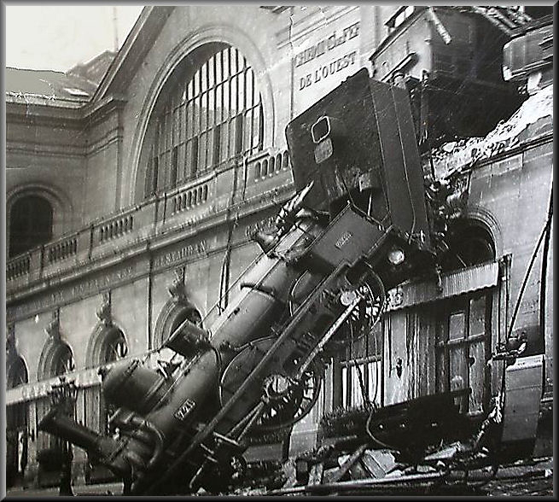

Executive functioning is a process, not an event.

The MAGNIFICENT SEVEN ELEMENTS OF Executive Functioning

1. Retrieval Practice
2. Four Pillars of Learning
3. PRIMED
4. STOP
5. Three Parts of Memory
6. Absolute Thinking
7. Frayer Model

Retrieval Practice

- Re-reading text & massed practice of a skill or new knowledge are by far the preferred study strategies of learners of all stripes, but they’re also among the least productive.
- Re-reading text & massed practice of a skill or new knowledge are by far the preferred study strategies of learners of all stripes, but they’re also among the least productive.
- Retrieval practice - recalling facts or concepts or events from memory - is a more effective learning strategy than review by re-reading.
Top 3 steps that support retrieval practice:
- Use Frequent Low-Stakes Testing
- Space Out Retrieval Attempts Over Time
- Mix Topics and Use Varied Contexts
            - 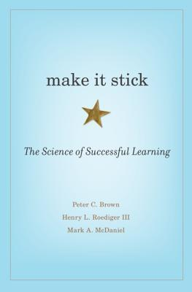

- 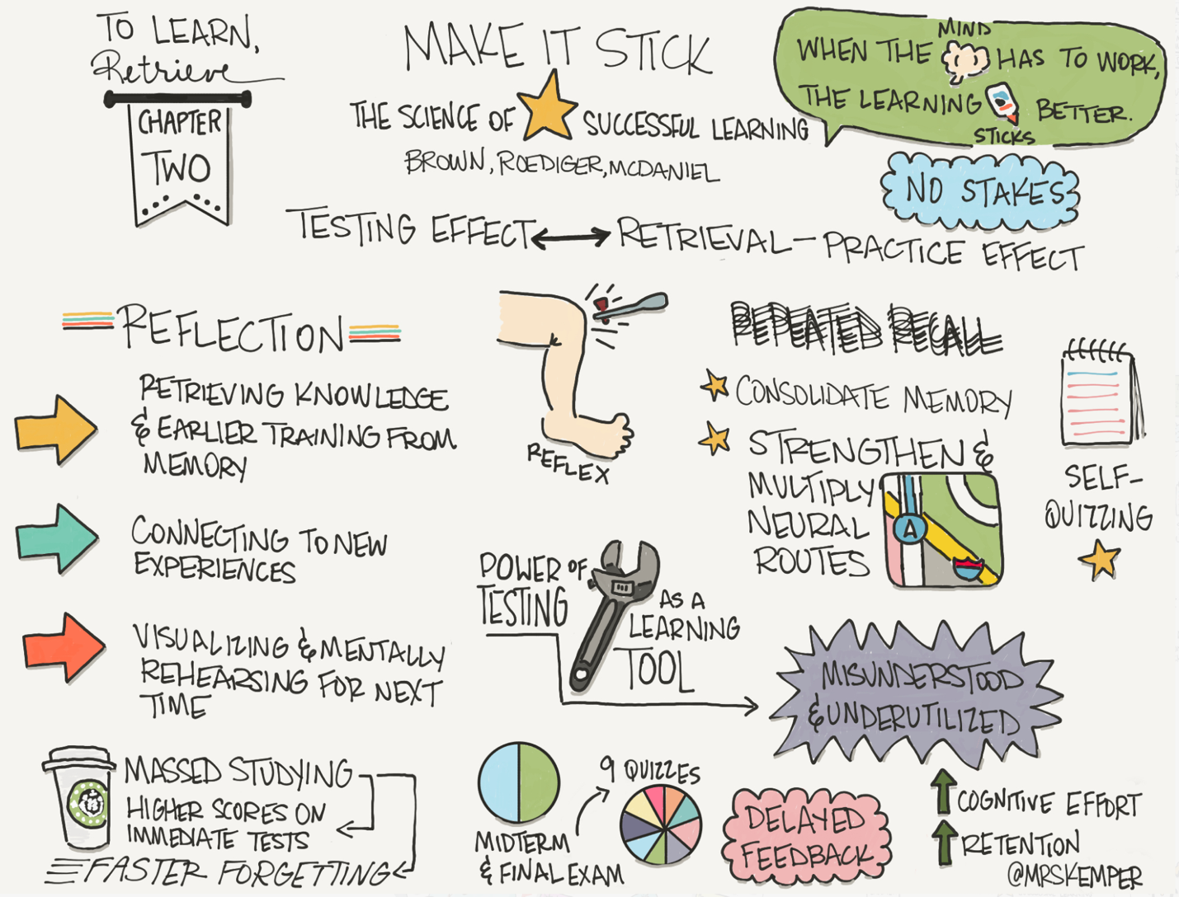
- Source: https://www.retrievalpractice.org/make-it-stick

Relevance to EF
- Implementing spaced repetition helps students develop planning and organizational skills.
- For example, scheduling periodic reviews of past material trains students to manage their time and prioritize effectively.

Four Pillars of Learning

- Attention:
Essential for focusing on relevant information & filtering out distractions. It ensures that the brain is selectively processing the most important aspects of the material being learned.
- Active Engagement:
Learner actively participating in the learning process. This can include activities such as problem-solving, discussion, & hands-on experiences, which help to deepen understanding and retention of the material.
- Error Feedback:
The process of receiving & using feedback to correct mistakes and refine understanding. It is a critical component for learning, as it allows learners to recognize errors and adjust their approach, leading to improved performance & mastery over time.
Error feedback is particularly relevant to EF. Mistakes are not failures but opportunities for the brain to learn and adapt, especially when combined with constructive feedback.
- Consolidation:
The process of solidifying & integrating new information into long-term memory, which often occurs during sleep. This pillar highlights the importance of adequate

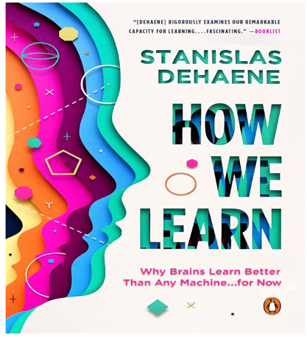

PRIMED

P | Pause and clear your mind
R | Remember what you did before; reflect on other options, viewpoints & values involved
I | Imagine what you will do; then do the task
M | Monitor how you are doing, your difficulties and adjustments
E | Evaluate outcomes and thinking: What went well? What was hard? What could be improved?
D | Develop connections

4. STOP

consider
SPACE: read the room
- What’s going on?
- Expected/unexpected?

TIME: get on the timeline
- What’s happening at this
moment in time?
- Pace/time of day?

OBJECTS: read the objects
- Look for objects/parts
- Location/purpose

PEOPLE: read the person
- What are they telling you?
- Look at face, body & appearance

From Sarah Ward, Director of Cognitive Connections --Internationally recognized expert on executive function skills. Co-authored the 360 Thinking Executive program and co-developed the Time Tracker Program and Get Ready, Do, Done instructional approach

5. Three Parts of Memory

STM  Short-term memory | AWM  Active working memory | LTM  Long-term memory
Posting an agenda  Classroom calendar  Checklists  Routines & procedures | Visuals, diagrams, mind maps  Automate as much as possible  Reduce cognitive load  Break down steps | Retrieval & spaced practice  Interleaved practice  Concept cards

Short-term memory – things intended to only be remembers for a few minutes or to be recorded so that the information can be consulted later. Things often stay in short-term memory by rehearsal, such as repeating a phone number until it is dialed (and then it is forgotten).

Active Working Memory – involves the ability to hold things together in your mind while working with them, such as steps in a process or attributes of a concept.

Long-term Memory – This is the information we want to store for later use, that builds our expertise and understanding of concepts, content and the world around us. To get information into long-term memory requires “elaborative rehearsal,” techniques of working with the material, connecting new material to old material building further cognitive connections creating deeper and more meaningful associations for better retention and recall.

Improved student retention and recall requires pedagogical techniques that help move information from active working memory to long-term memory.

Project vs. Task
Learning involved engaging in tasks

- A project is a final product.
  - It is something you finish.

- A task is one of many steps that are taken to start & eventually finish a project.
  - It is something you do. Tasks provide the ability to move information into long-term memory. Learning to master a number of tasks can build mastery and expertise.

6. Absolute Thinking

One of the biggest challenges to students, particularly neurodiverse students and those experiences anxiety or ADHD is

UNCERTAINTY

Absolute thinking is black-white thinking that does not recognize nuances. It is related to operational thinking, the basic understanding of formal concepts.

Post-Formal Thinking: College students are challenged to engage in abstract and relative thinking. The hallmark of this type of thinking is the ability to think abstractly or to consider possibilities and ideas about circumstances never directly experienced. Post-formal thinking requires the recognition of nuances, consideration of hypotheticals and abstractions, synthesis of information, is dialectical and deals with more complex materials and multiple, systemic relationships between concepts and ideas.

How can we best support students who exhibit Absolute Thinking to moving to post-formal thinking in a nuanced, relative world?

7. Frayer Model

Step 1: Introduce the Term/Concept
Write the key vocabulary word or concept in the center of the Frayer Model. Explain its importance and relevance to the lesson.
Step 2: Define the Term
Instruct students to write a clear definition in their own words in the top-left quadrant of the model. Encourage them to use textbook definitions as a reference but personalize their understanding.
Step 3: Provide Examples & Non-Examples
- In the bottom-left quadrant, students write examples that illustrate the term. These could be real-life examples, synonyms, or related concepts.
- In the bottom-right quadrant, students write non-examples to clarify misconceptions and contrast the term with what it is not.
Step 4: Describe Characteristics or Draw a Picture
In the top-right quadrant, students list key characteristics of the term (e.g., attributes, facts, or features) OR draw a visual representation to help solidify their understanding.

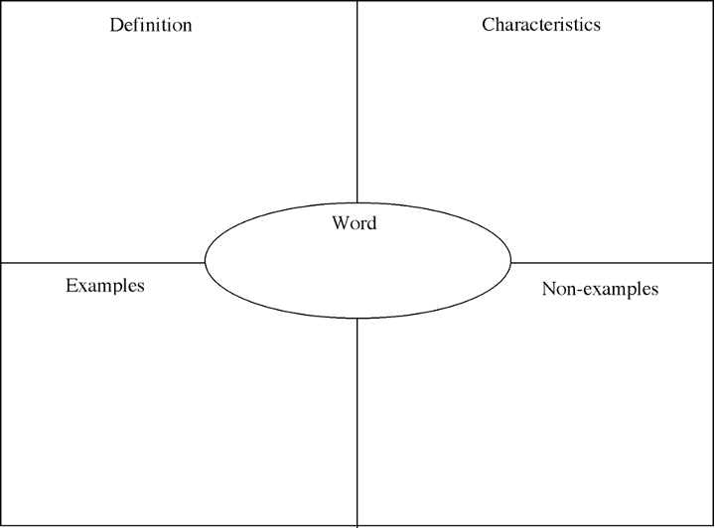

Identifying Executing Functioning Strengths and Needs A Metacognitive Inventory

Adapted from Schraw, G. & Dennison, R.S. (1994). Assessing metacognitive awareness. Contemporary Educational Psychology, 19, 460-475.

INTRODUCTION:

This inventory/survey is adapted from the work of Schraw & Dennison and introduces faculty to accessing students executive functioning needs. Faculty may find this useful to understand the dimensions of executive function that affect student success and to help assess the needs of their students. This survey can be provided to students to help identify how they learn best and what supports they need and/or need to advocate for.
Having identified specific areas where support is needed, the EF toolbook offers tools and techniques for addressing specific needs.

Knowledge About Cognition
Declarative Knowledge
- The factual knowledge the learner needs before being able to process or use critical thinking related to the topic
- Knowing about, what, or that
- Knowledge of one’s skills, intellectual resources, and abilities as a learner
- Students can obtain knowledge through presentations, demonstrations, discussions
Procedural Knowledge
- The application of knowledge for the purposes of completing a procedure or process
- Knowledge about how to implement learning procedures (e.g. strategies)
- Requires students to know the process as well as when to apply the process in various situations
- Students can obtain knowledge through discovery, cooperative learning, and problem-solving

Conditional Knowledge
- The determination under what circumstances specific processes or skills should transfer
- Knowledge about when and why to use learning procedures
- Application of declarative and procedural knowledge with certain conditions presented
- Students can obtain knowledge through simulation

Metacognitive Awareness Inventory (MAI) Scoring Guide
Directions: For each True on the MAI give yourself 1 point on the following charts. For each False, give yourself 0 points in the Score column. In the box, total the score of each category.

Declarative Knowledge |  | Score
1. | I understand my intellectual strengths and weaknesses.
2. | I know what kind of information is most important to learn.
3. | I am good at organizing information.
4. | I know what the teacher expects me to learn.
5. | I am good at remembering information.
6. | I have control over how well I learn.
7. | I am a good judge of how well I understand something.
8. | I learn more when I am interested in the topic.
Total |  | /8

Procedural Knowledge |  | Score
1. | I try to use strategies that have worked in the past.
2. | I have a specific purpose for each strategy I use.
3. | I am aware of what strategies I use when I study.
4. | I find myself using helpful learning strategies automatically.
Total |  | /4

Conditional Knowledge |  | Score
1. | I learn best when I know something about the topic.
2. | I use different learning strategies depending on the situation.
3. | I can motivate myself to learn when I need to.
4. | I use my intellectual strengths to compensate for my weaknesses.
5. | I know when each strategy I use will be most effective.
Total |  | /5

Debugging Strategies |  | Score
1. | I ask others for help when I don’t understand something.
2. | I change strategies when I fail to understand.
3. | I re-evaluate my assumptions when I get confused.
4. | I stop and go back over new information that is not clear.
5. | I stop and reread when I get confused.
Total |  | /5

Regulation of Cognition
Planning
- Planning, goal setting, and allocating resources prior to learning
Information Management Strategies
- Skills and strategy sequences used to process information more efficiently (e.g., organizing, elaborating, summarizing, selective focusing)
Comprehension Monitoring
- Assessment of one’s learning or strategy use
Debugging Strategies
- Strategies used to correct comprehension and performance errors
Evaluation
- Analysis of performance and strategy effectiveness after a learning episode

Planning |  | Score
1. | I pace myself while learning in order to have enough time.
2. | I think about what I really need to learn before I begin a task.
3. | I set specific goals before I begin a task.
4. | I ask myself questions about the material before I begin.
5. | I think of several ways to solve a problem and choose the best one.
6. | I read instructions carefully before I begin a task.
7. | I organize my time to best accomplish my goals.
Total |  | /7

Information Management Strategies |  | Score
1. | I slow down when I encounter important information.
2. | I consciously focus my attention on important information.
3. | I focus on the meaning and significance of new information.
4. | I create my own examples to make information more meaningful.
5. | I draw pictures or diagrams to help me understand while learning.
6. | I try to translate new information into my own words.
8. | I use the organizational structure of the text to help me learn
9. | I ask myself if what I’m reading is related to what I already know.
10. | I try to break studying down into smaller steps.
11. | I focus on overall meaning rather than specifics.
Total |  | /11

Comprehension Monitoring |  | Score
1. | I ask myself periodically if I am meeting my goals.
2. | I consider several alternatives to a problem before I answer.
3. | I ask myself if I have considered all options when solving a problem.
4. | I periodically review to help me understand important relationships.
5. | I find myself analyzing the usefulness of strategies while I study.
6. | I find myself pausing regularly to check my comprehension.
7. | I ask myself questions about how well I am doing while learning something new.
Total |  | /7

Evaluation |  | Score
1. | I know how well I did once I finished a test.
2. | I asked myself if there was an easier way to do things after I finished a task.
3. | I summarize what I’ve learned after I finish.
4. | I ask myself how well I accomplish my goals once I’m finished.
5. | I ask myself if I have considered all options after I solve a problem.
6. | I ask myself if I learned as much as I could have once I finished a task.
Total |  | /6

